# Scenario testing with bioeconomic impact evaluation of spatial plans on fisheries: The Irish Demersal Celtic Sea fisheries

The full implementation of a landing obligation in EU waters from 1 January 2019 associated with the TACs system in force in the northern EU waters may sometimes lead to a substantial quota underutilization, especially in the Celtic Sea, when the fishing is “choked” by the most restrictive quotas. If ‘choking’ is the result of the decline in abundant commercial species, or TACs lagging behind increasing fishing opportunities, there may be possibilities for the fishermen to avoid catching these species. We have developed a range of spatial fisheries models, integrating biological information with fisher decision-making dynamics. The models can simulate a range of possible management measures (both coercive and incentive) that would help such avoidance. We present the outcomes of the DISPLACE agent-based modelling platform for simulating bio-economic fisheries dynamics and clarifying options for sustainable and viable fisheries in the Celtic Sea. The Celtic Sea ecosystem consists of complex biological interactions among several fish species, including commercially important species and unwanted bycatch species. This has encouraged us to integrate a size-spectrum modeling approach that accounts for potential predation effects among species when fishing pressure is displaced. The approach is suited explicitly for evaluating whether the benefits of spatial plans and incentives compensate for the potential biological costs of displacing fishing to the surroundings and possibly other stocks. The models generate an overview of short to medium-term impacts by aggregating the individual fishing operations, and at the same time, detailing the spatiotemporal dimensions for particular fishing activities, harbour communities or national fleets. We found that computer simulations can support ecological-economical evaluations of spatial management strategies to elicit some viable paths when managing fisheries and, for example, avoiding quota underutilization and associated economic losses. We discuss the potential to facilitate nudging, incentivizing and self-government of the stakeholders. In these simulations, the fishers are provided with fishing credits and spatially varying tariff maps with which we can test in the model. The final model framework should ultimately anticipate the efficiency and effectiveness of the mitigation measures and the residual impacts on ecosystems at spatial and temporal scales relevant to fisheries interests and policymakers, in the Celtic Sea and beyond.

In the present case study, we address the issue of quota underutilization from choked species that would arise from annual decisions on TACs not matching the opportunities of individual fishers. We, therefore, explore the potential benefits of spatial avoidance (or spatial selectivity) by displacing the fishing to other areas but also measuring the change of pressure on other ecosystem components, i.e., including i) effects on other species via trophic interactions effects ii) effects on benthic habitats. An innovative fisheries management measure, a fishing credits system (Kraak et al 2012, 2014 & 2015) is used in this context to help to incentivize displacing the fishing towards areas minimizing the final net effects and is further contrasted against testing spatial management with closed areas.

We further use the DISPLACE model built for the Celtic Sea to test whether the use of spatiotemporal management measures could prevent a choke. As noted in PROBYFISH Task 4.1, we have not identified any species or stocks in the Celtic Sea that are not also protected under a “min” scenario by the restraint on fishing imposed by the TACs on the previously TAC managed species. However, the principle of using spatiotemporal management as such may still be tested by using one of the current (TAC managed) stocks that are in the models. Cod, in many ways, would be a suitable surrogate to investigate spatiotemporal management. As described under the PROBYFISH Task 4.3. cod fits many of the characteristics of a vulnerable bycatch species. We use the CPUE and discarding hotspots identified in the DISCARDLESS project (Calderwood et al. 2019) to identify suitable candidate areas for closure. These can be determined based on where cod catches are consistently high over time on both an annual and a quarterly basis, allowing both a spatial and a temporal context to the analysis. These maps are based on total catches for above and below MCRS cod, and for the two main gears used in the Celtic Sea; whitefish and Nephrops otter trawls (TR1 & TR2). DISPLACE then complements this by forecasting the fish and fisheries dynamics for a few years ahead, to determine if this would protect the cod in the absence of a TAC.

## 1. Conditioning fisheries

### 1.2. Fishing vessels

Fishing vessels were considered for the Irish fishing fleet alone. Information on vessels currently in service was gathered from the Irish fleet register, downloaded from the Irish department for agriculture (DAFM, 2017) as well as the European Commission (EC, 2017). For the RTI-model, the fishing vessels were categorized according to length (Table 1).

|  |  |
| --- | --- |
| Length class | Length range |
| Very small | <12 m |
| Small | 12 m – 14.99 m |
| Medium | 15m – 16.75 m |
| Large | >=16.76 m |

Table 1.2.1: Length categories of fishing vessels with the corresponding length ranges.

### I.3. Landings

Landings in kg week-1 were provided for the years 2006 – 2015 using the Vessel Monitoring System (VMS) and the landings information from ports, maintained by the Marine Institute (MI, 2016). The data were resolved by longitude and latitude to two decimals, species, gear and vessel length category. Fishing effort was provided in hours so that the landings could be standardized to landings per unit effort (LPUE). The temporal resolution was limited by data protection requirements as the MI cannot provide data identifiable to the individual vessel to other institutions. Landings of foreign fishing fleets were extracted from the Data Collection Framework (DCF, 2016). This data was only available up to 2014 and for vessels >15 m and resolved by quarter and ICES rectangle. Landings were in tons but effort, although available from DCF, was impossible to match with the landings data.

### 1.4 Fishing Gears

The RTI-system is mostly applicable to mobile gears but can be adapted for immobile gears. Gears used in the RTI-system, as well as in DISPLACE, were grouped into nine categories (Table 2). We did not include traps, portable and boat operated lift nets, and purse seines. All these gears had very few records.

Table 1.4.1: Gear categories and codes. Ambiguous gears contain unspecified otter trawls, pair trawls, unknown and miscellaneous gears.

|  |  |
| --- | --- |
| Category | Code (DISPLACE) |
| Ambiguous | A |
| Beam Trawls | BT |
| Bottom Otter Trawls | BOT |
| Dredges | D |
| Gill Nets | GN |
| Longline | LL |
| Pelagic trawls | PT |
| Pots | P |
| Seines | S |

### 1.5. Gear selectivity

Table 1.5.1 Species-specific otter Bottom trawl gear selectivity ogives over body size bins. The size of the size group bins depends on the species but is chosen to be 5 cm for most of them.

|  |  |  |  |  |  |  |  |  |  |  |  |  |  |  |
| --- | --- | --- | --- | --- | --- | --- | --- | --- | --- | --- | --- | --- | --- | --- |
| aru_oth | 0.0053 | 0.0185 | 0.0628 | 0.1922 | 0.4578 | 0.7498 | 0.9140 | 0.9742 | 0.9926 | 0.9979 | 0.9994 | 0.9998 | 1.0000 | 1.0000 |
| ary_celt | 0.0000 | 0.0001 | 0.0081 | 0.4731 | 0.9900 | 0.9999 | 1.0000 | 1.0000 | 1.0000 | 1.0000 | 1.0000 | 1.0000 | 1.0000 | 1.0000 |
| msf_celt | 0.0444 | 0.0672 | 0.1003 | 0.1473 | 0.2110 | 0.2929 | 0.3908 | 0.4984 | 0.6062 | 0.7045 | 0.7869 | 0.8512 | 0.8985 | 0.9168 |
| lyy_celt | 0.0011 | 0.0072 | 0.0446 | 0.2302 | 0.6570 | 0.9247 | 0.9874 | 0.9980 | 0.9997 | 1.0000 | 1.0000 | 1.0000 | 1.0000 | 1.0000 |
| boc_nea | 0.0021 | 0.0104 | 0.0509 | 0.2150 | 0.5832 | 0.8772 | 0.9733 | 0.9947 | 0.9990 | 0.9998 | 1.0000 | 1.0000 | 1.0000 | 1.0000 |
| gur_comb | 0.0000 | 0.0000 | 0.0000 | 0.0000 | 0.0000 | 0.0000 | 0.0000 | 0.0000 | 0.0000 | 0.0000 | 0.0000 | 0.0000 | 0.0000 | 0.0000 |
| her_irls | 0.0000 | 0.0000 | 0.0000 | 0.0400 | 0.4100 | 0.5500 | 0.1300 | 0.1300 | 0.1300 | 0.1300 | 0.1300 | 0.1300 | 0.1300 | 0.1300 |
| cod_7ek | 0.0200 | 0.0200 | 0.0200 | 0.0200 | 0.0200 | 0.0200 | 0.0200 | 0.1800 | 0.1800 | 0.1800 | 0.1800 | 0.7800 | 0.7800 | 0.7800 |
| rjn_678abd | 0.0000 | 0.0000 | 0.0000 | 0.0001 | 0.0016 | 0.0220 | 0.2448 | 0.8239 | 0.9854 | 0.9990 | 0.9999 | 1.0000 | 1.0000 | 1.0000 |
| meg_78 | 0.0491 | 0.0713 | 0.1025 | 0.1453 | 0.2020 | 0.2736 | 0.3592 | 0.4548 | 0.5539 | 0.6488 | 0.7333 | 0.8036 | 0.8590 | 0.8814 |
| dab_nsea | 0.0000 | 0.0000 | 0.0000 | 0.0000 | 0.0000 | 0.0000 | 0.0000 | 0.0000 | 0.0000 | 0.0000 | 0.0000 | 0.0000 | 0.0000 | 0.0000 |
| mon_78 | 0.0000 | 0.0009 | 0.0209 | 0.3285 | 0.9180 | 0.9961 | 0.9998 | 1.0000 | 1.0000 | 1.0000 | 1.0000 | 1.0000 | 1.0000 | 1.0000 |
| had_7bk | 0.0000 | 0.0000 | 0.0000 | 0.3640 | 0.3640 | 0.9800 | 1.0000 | 1.0000 | 1.0000 | 1.0000 | 1.0000 | 1.0000 | 1.0000 | 1.0000 |
| whg_7ek | 0.0000 | 0.0000 | 0.0000 | 0.0000 | 0.0070 | 0.0860 | 0.4330 | 0.7690 | 0.6380 | 0.6380 | 0.6380 | 0.6380 | 0.6380 | 0.6380 |
| hke_nrtn | 0.0001 | 0.0005 | 0.9489 | 0.9934 | 0.9992 | 0.9999 | 1.0000 | 1.0000 | 1.0000 | 0.0000 | 0.0044 | 0.0341 | 0.2218 | 0.6970 |
| whb_comb | 0.0000 | 0.0000 | 0.0000 | 0.0000 | 0.0000 | 0.0000 | 0.0000 | 0.0000 | 0.0000 | 0.0000 | 0.0000 | 0.0000 | 0.0000 | 0.0000 |
| nep_16 | 0.1336 | 0.2435 | 0.4019 | 0.5839 | 0.7455 | 0.8595 | 0.9274 | 0.9638 | 0.9823 | 0.9915 | 0.9959 | 0.9980 | 0.9991 | 0.9993 |
| nep_17 | 0.1336 | 0.2435 | 0.4019 | 0.5839 | 0.7455 | 0.8595 | 0.9274 | 0.9638 | 0.9823 | 0.9915 | 0.9959 | 0.9980 | 0.9991 | 0.9993 |
| nep_19 | 0.1336 | 0.2435 | 0.4019 | 0.5839 | 0.7455 | 0.8595 | 0.9274 | 0.9638 | 0.9823 | 0.9915 | 0.9959 | 0.9980 | 0.9991 | 0.9993 |
| nep_2021 | 0.1336 | 0.2435 | 0.4019 | 0.5839 | 0.7455 | 0.8595 | 0.9274 | 0.9638 | 0.9823 | 0.9915 | 0.9959 | 0.9980 | 0.9991 | 0.9993 |
| nep_22 | 0.1336 | 0.2435 | 0.4019 | 0.5839 | 0.7455 | 0.8595 | 0.9274 | 0.9638 | 0.9823 | 0.9915 | 0.9959 | 0.9980 | 0.9991 | 0.9993 |
| ple_celt | 0.0241 | 0.0465 | 0.0877 | 0.1594 | 0.2722 | 0.4245 | 0.5927 | 0.7416 | 0.8498 | 0.9178 | 0.9566 | 0.9775 | 0.9885 | 0.9918 |
| pol_2767 | 0.0025 | 0.0117 | 0.0531 | 0.2104 | 0.5588 | 0.8576 | 0.9662 | 0.9927 | 0.9985 | 0.9997 | 0.9999 | 1.0000 | 1.0000 | 1.0000 |
| pok_celt | 0.0255 | 0.0481 | 0.0888 | 0.1582 | 0.2661 | 0.4115 | 0.5742 | 0.7223 | 0.8338 | 0.9063 | 0.9491 | 0.9730 | 0.9858 | 0.9897 |
| syc_celt | 0.0023 | 0.0111 | 0.0521 | 0.2125 | 0.5700 | 0.8669 | 0.9697 | 0.9937 | 0.9987 | 0.9997 | 0.9999 | 1.0000 | 1.0000 | 1.0000 |
| sol_celt | 0.0000 | 0.0000 | 0.0000 | 0.0000 | 0.0000 | 0.0380 | 0.2280 | 0.2300 | 0.2300 | 0.2300 | 0.2300 | 0.2300 | 0.2300 | 0.2300 |
| nop_34oct | 0.0001 | 0.0013 | 0.0238 | 0.3107 | 0.8930 | 0.9936 | 0.9997 | 1.0000 | 1.0000 | 1.0000 | 1.0000 | 1.0000 | 1.0000 | 1.0000 |
| pod_celt | 0.0000 | 0.0010 | 0.0213 | 0.3261 | 0.9150 | 0.9958 | 0.9998 | 1.0000 | 1.0000 | 1.0000 | 1.0000 | 1.0000 | 1.0000 | 1.0000 |

Table: Extracted from Vigier et al. in prep: Selectivity ogive were obtained from parameters identified in the literature:

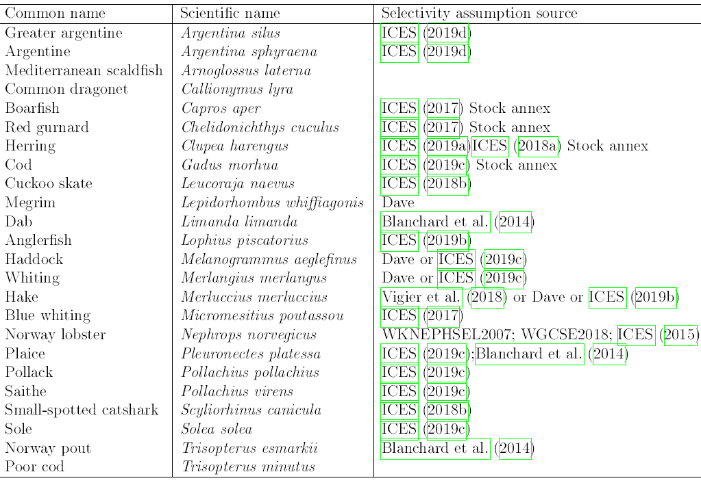

The additional ones labeled “Dave” were provided by BIM pers comm.

### 1.6. Fish prices

Prices for small, medium and large fish were compiled from the European Market Observatory for Fisheries and Aquaculture Products (EUMOFA, 2018) and for Norway pout from Norges Sildesalgslag (2018). The three size categories were established for individual species using the size grades in the Common Fisheries Policy (CFP; EU Council, 1996). Prices were given monthly, and they were averaged across the years 2008-2016 were available. For Norway pout, only one price for raw material for fish meal and oil production could be found.

## 2. Conditioning fish stocks

### 2.1. Fish stocks

The model contains 23 species of fish (21 teleosts, 2 elasmobranchs) as well as *Nephrops norvegicus* (Table 3). Model parameters were taken from stock annexes (F0, catch, landings, biomass, SSB, natural mortality and FMSY) or from FishBase (coefficients for von Bertalanffy growth and length/weight conversion, L∞ and length at age 0). The species were selected to represent the fish community in the Celtic Sea, in biomass, as well as numbers but excluding species with stocks covering much larger areas than the Celtic Sea (e.g., mackerel) or insufficient data for parameterization. Previous papers modelling the fish community of the Celtic Sea (Trenkel and Rochet 2003, Houle et al. 2016) were taken as guidelines.

Table 2.1.1 List of modelled species.

|  |  |  |
| --- | --- | --- |
| Common Name | Species Name | (Sub)class |
| Anglerfish | *Lophius piscatorius* | Teleostei |
| Argentine | *Argentina sphyraena* | Teleostei |
| Blue whiting | *Micromesistius poutassou* | Teleostei |
| Boarfish | *Capros aper* | Teleostei |
| Cod | *Gadus morhua* | Teleostei |
| Cuckoo ray | *Leucoraja naevus* | Elasmobranchii |
| Dab | *Limanda limanda* | Teleostei |
| Dragonet | *Callionymus lyra* | Teleostei |
| Greater Argentine | *Argentina silus* | Teleostei |
| Haddock | *Melanogrammus aeglefinus* | Teleostei |
| Hake | *Merluccius merluccius* | Teleostei |
| Herring | *Clupea harengus* | Teleostei |
| Lesser spotted dogfish | *Scyliorhinus canicula* | Elasmobranchii |
| Megrim | *Lepidorhombus whiffiagonis* | Teleostei |
| Norway lobster | *Nephrops norvegicus* | Malacostraca |
| Norway pout | *Trisopterus esmarkii* | Teleostei |
| Plaice | *Pleuronectes platessa* | Teleostei |
| Pollack | *Pollachius pollachius* | Teleostei |
| Poor cod | *Trisopterus minutus* | Teleostei |
| Red gurnard | *Chelidonichthys cuculus* | Teleostei |
| Saithe | *Pollachius virens* | Teleostei |
| Scaldfish | *Arnoglossus laterna* | Teleostei |
| Sole | *Solea solea* | Teleostei |
| Whiting | *Merlangius merlangus* | Teleostei |

### 2.2. Initial distributions and stock numbers

The spatial domain of the models was limited by 12° W to 5° W and 48° N to 53.5° N (52.5° N east of Ireland). Initial distributions were modeled twice. Once fisheries dependent, by kriging VMS derived landings onto an approximated VMS-grid (0.03° Lon X 0.02° Lat.) and secondly onto a 3 km hexagonal grid using data from the Irish Groundfish Survey (IGFS), extracted from the ICES database and cleaned up by Marine Scotland (Moriarty and Greenstreet, 2016). As the species composition across the Celtic Sea varies, four large areas were delimited, following Trenkel et al. (2004), with a fifth area covering the shelf break between the 200 m and 500 m isobaths. In the RTI-model these areas constitute separate models, which are only connected at the points where data is passed to the fisheries model in DISPLACE and the results from that model collected for redistribution over the RTI-grid.

For the initial numbers in DISPLACE, the size spectrum model was run for a one-time step. The numbers before fishing, which in the SSM itself is only implemented as the removal of a random fraction of individuals per grid cell, were then extracted to inform the initial population in the fisheries model in DISPLACE.

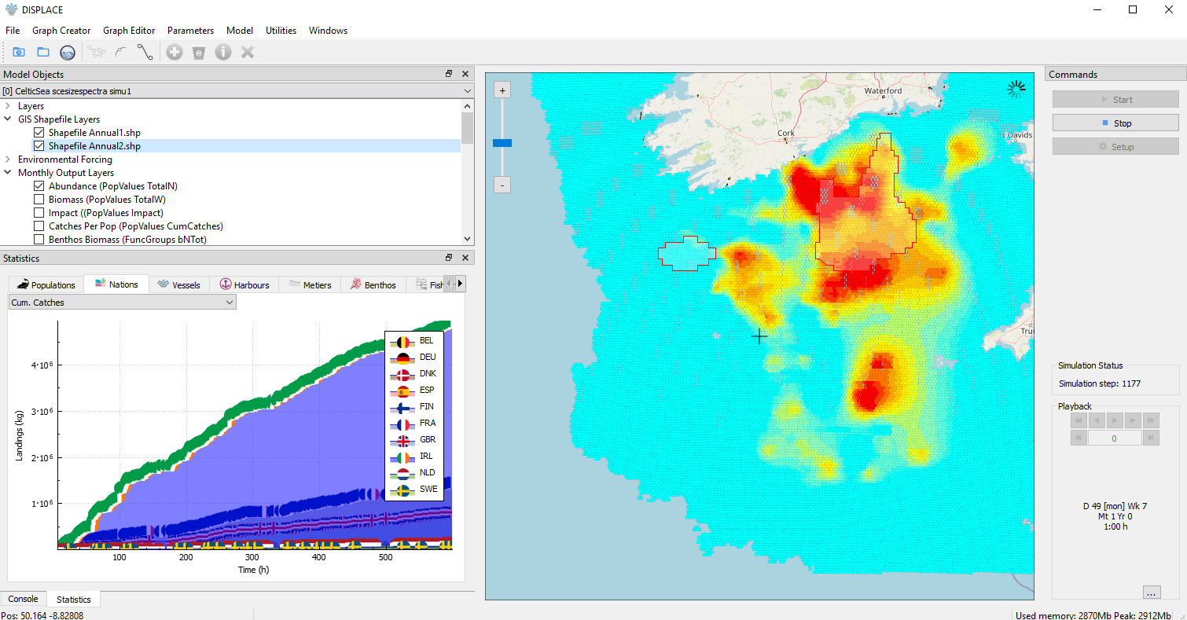

Figure 2.2.1. Screenshot of the DISPLACE graphical user interface showing the abundance field for one of the simulated populations; cod 7ek, initialized from geokriging on survey CPUE points. The closed areas for the annual closure scenario are shown (the two red border polygons)

### 2.3. Size-spectrum parameterisation

The DISPLACE size-spectrum module and the parameterization for Celtic Sea stocks are derived from Blanchard et al. Supplementary Materials. The size spectrum modelling is applied to each DISPLACE location (spatial grid), and at a monthly time step during the simulations for deducing fish mortality from the predation (M2) that each stock experiences. Natural mortality (M) includes background mortality resulting from other causes than predation mortality.

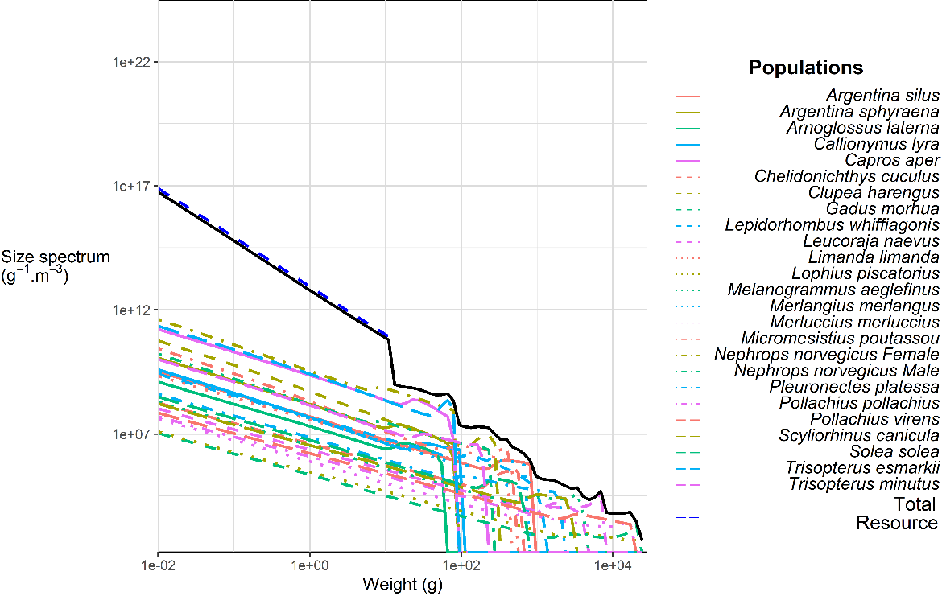

Figure 2.3.1. From Vigier et al. Size-spetrum parameterization across the studied species

## 2.4. Conditioning other ecosystem components

Broad-scale habitats and seabed substrates were both downloaded from the European Marine Observation and Data Network (EMODnet, 2016). Hydrographic data, namely depth of the photic zone, mixed layer depth, bottom and average temperature, as well as salinity, were also extracted from CMEMS (Marcos et al., 2016).

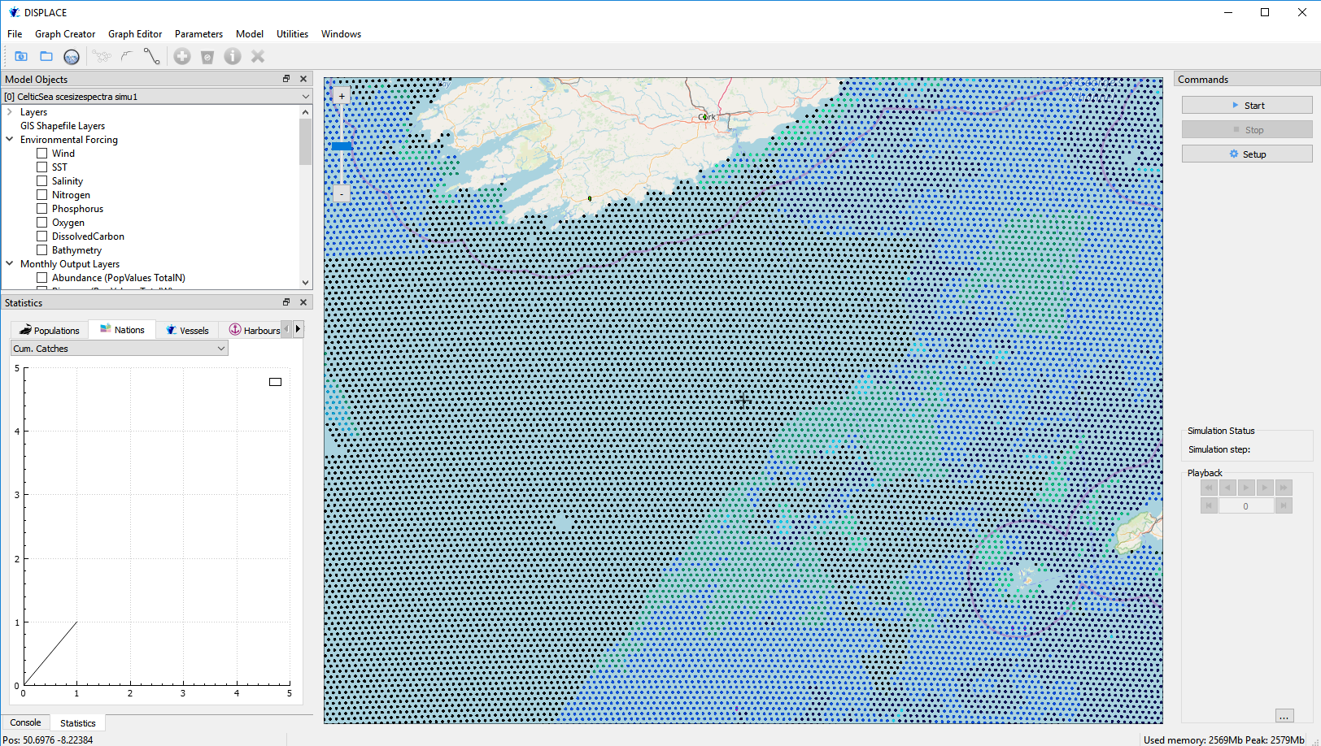

Figure 2.4.1. Screenshot of the DISPLACE graphical user interface showing the locations coloured by type of seabed habitats informed from the EUNIS level 5 categories.

## 2.5. Baseline run

The baseline runs account for trophic interactions among stocks by deducing predator-prey mortality (so-called M2 mortality) from the modelling of the size-spectrum (Blanchard et al. 2014).

Some initializations are required for the simulation of a fishing credits system. Hence, the initial fishing credits allocation is assumed as the total historical effort of each vessel plus a 20% bonus to provide flexibility to the vessels at the start of the simulations. The first tariff maps are drawn from a Baseline simulation identifying the main discards area, and each grid cell is assigned a tariff among categories 0.1, 0.5,1,2,5, 10. The tariff map is updated each week, with the tariff in a given cell moving from one category to the next, either up or down, or staying unchanged. An annual harvest control rule is applied each year to provide tariff categories that represent greater or lesser effort, this is done using a percentage change decided at the start of the year. Finally, the total annual fishing credits per vessel are kept constant as we would not normally expect to change the total annual fishing credits, unless more vessels had entered the fleet, or some had left, which does not happen in the simulations.

The baseline implements a Total Allowable Catches (TAC) regime for all the species regulated under a TAC in the Celtic Sea, with TACs set from predefined Fmsy targets.

## 2.6. Scenarios

By default, all vessels are expected to try to maximize their economic gain by; i) focusing fishing on grounds with highest expected profits among their known space of possibilities and from the specific catch rates they experienced in these zones in previous trips; ii) or on the closer fishing grounds; iii) or finally depending on the historical frequency they used to visit the grounds they prefer. On the biological side, the population dynamics are affected by the removals from the fishing, but also from predators by applying size-spectrum operational biological module to the dynamics. We then contrast the baseline scenario with scenarios testing alternative biological operating models and fisheries management options under a TAC management regime, including the 2013 EU CFP Landing Obligation (i.e. counting the unmarketable fish against the quotas):

* “Baseline + Predation-free” scenario
* “Baseline + Avoiding choke species” scenario
* “Baseline + Stop if choked” scenario
* “Baseline + Avoidance + Stop if choked” scenario
* “Baseline + Avoid High Tariffs Areas” scenario
* “Baseline + Focus on High Tariffs Areas” scenario
* “Baseline + annual closed areas for cod” scenario
* “Baseline + quarterly-based closed areas for cod” scenario

The predation is activated by default and constitutes the baseline. If the predation minors in a scenario then no M2 from size spectrum is applied, the dynamics of the stock are therefore assumed independent from others.

Avoiding the choke species is implemented in the simulation as the simulated fishing vessels deciding where to fish depending on the risk of bycatching a choke species. If the risk is too high (discard >20% in weight of the total catch), an alternative ground is chosen.

An alternative to the implementation of the landing obligation could be to suggest a fishing credit system that would assign credits each year to each vessel for her to spend freely. The decrease in credits depending on the effort deployed can also depend on the areas the fishing is occurring. In the simulation, is it more costly in credits to fish on areas where the risk of catching unmarketable fish is high (discards). Because it is not clear if the fishing vessels should better focus on high tariffs areas, which are also likely to be productive areas, or on the contrary avoid these high tariffs, both situations have been tested.

The Landing Obligation is implemented in all the scenarios. Therefore the unmarketable fish are counted against the quotas. However, the fishing vessels can independently react when choked. If the “stop if choked” scenario applies, then a fishing vessel will stay on the quayside as soon as a quota of one of the target stocks is exhausted. The vessel will continue fishing and discard overboard the non-allowed catches otherwise. The “stop if choked” situation corresponds to a fully enforced Landing Obligation, which we did not assume in the alternative management (closures or fishing credits system).

Avoidance decision probabilities are decided by decision trees (type “ChooseGround”) embedded in the DISPLACE software that is used by each vessel each time a vessel is taking the decision to go fishing.

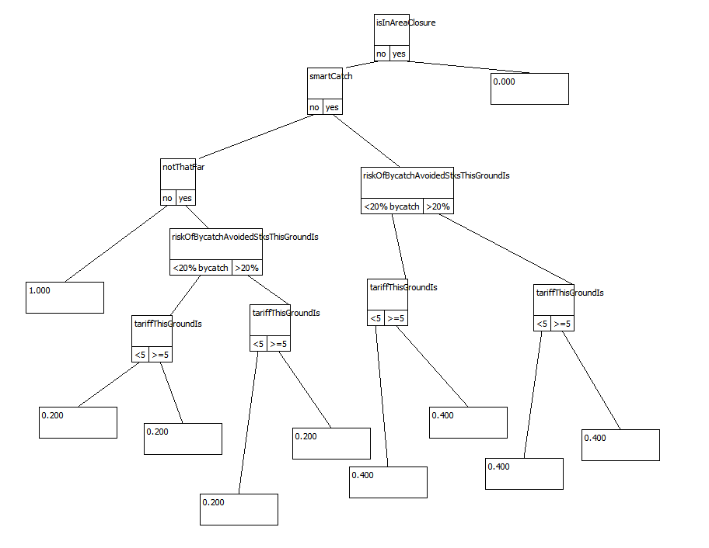

Figure 2.6.1. “ChooseGround” DISPLACE decision trees used in the baseline scenario.

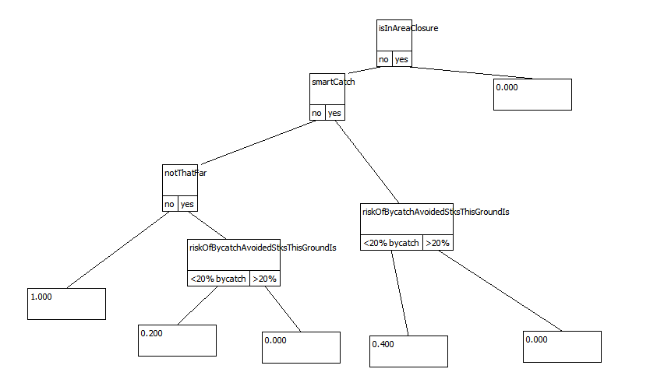

Figure 2.6.2. “ChooseGround” DISPLACE decision trees used in the bycatch avoidance scenario.

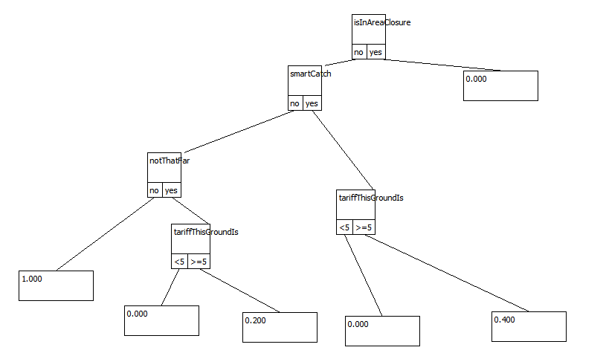

Figure 2.6.3. “ChooseGround” DISPLACE decision trees used in the high tariff targeted scenario.

|  |  |
| --- | --- |
| **Closed areas** | **MCRS threshold areas** |
|  |  |
|  |  |
|  |  |
|  |  |
|  |  |

Figure 2.6.4. Designed closed areas based on MCRS thresholds, further tested in DISPLACE closure scenarios

To design the closure scenarios, we looked at TR1 and TR2 fleet segment, and catch rates above and below MCRS. We mapped the annual pattern, and then individually by quarter. We used the top 20% CPUE for the >MCRS, and the top 60% for the <MCRS to get maps that looked sensible. We then designated from those where the most apparent areas to close would be. Hence, these closed areas are designed to implement the avoidance of unwanted undersized catch, along with the avoidance of large densities of adult cod that would lead to a rapid choke. Both these aims would also tend to protect the cod as adults and as juveniles. This would also tend to minimize the possible effect of effort displacement, as any other likely choice by the displaced vessels would be less likey to have high cod CPUE, with either < or > MCRS. Either of these two incentives when implemented separately might indeed lead to unintended impacts, i.e. displacing from >MCRS to <MCRS areas. This would tend to be counterproductive and possibly reduce the benefits for the overall cod stock.

## 2.7. Simulation outcomes

The simulation first shows that accounting for the predation effects affecting the stock dynamics (Baseline size spectra) would result in the fishing vessels requiring more effort to catch their quotas (Figure 2.7.1). Essentially the predators are acting as competitors to the fishing vessels for key commercial fish. This also shows that focusing on single-stock dynamics, and neglecting predator-prey interactions can lead to overly optimistic perceptions of stock levels.

The risk of the fisheries being choked is very high as the simulations show that a large, dramatic effort cut occurs (Figure 2.7.1c) when the fleet reacts to choke by staying on the quayside, as the landing obligation would suggest if fully enforced, or if no quota swap or quota leasing would be allowed (which is permitted in the Celtic Sea). If fleet stops the fishing mortality on cod goes to zero, and other fishing mortalities are getting reduced for other stocks such as hake and monkfish (Figure 2.7.2) due to large quota underutilization resulting from underutilizing spatial fishing opportunities (Figure 2.7.2) when the fleet is choked. A subsequent gain in SBB is observed, but will never be used if the choke situation propagates. However, the repeated choked fleets induce higher Fs on the long term on haddock and whiting (Figure 2.7.2), likely induced by altered trophic interactions. We also note that the gain on cod SSB is very large, likely because the initial cod SSB is at low level and quite uncertain. Nevertheless, by likely minimizing the risk for a drastic change in foodweb interactions compared to the baseline, the most significant gain in SSB for cod, haddock and whiting is eventually from the closed areas designed on cod (Figure 2.7.1) from reduced Fs as discussed below. Other stocks are impacted in different directions (Table 2.7.1).

Simulations show then that there might be a possibility to mitigate fishing impacts on some stocks and continue profitable fishing by reacting along with the fishing by avoiding areas with a high risk of catching the choking stocks from their experienced historical catch rates on them, but, to a much larger extent, by implementing a fishing credits system that would inform for this risk in real time (Figure 2.7.2) or with some imposed closed areas to protected cod (Figure 2.7.3 and Figure 2.7.4 specific to cod).

Implementing a fishing credits system (RTI) as an alternative to a fully enforced landing obligation is shown to mitigate the fishing impacts on the stocks. This gives somewhat different results depending on the vessel tactics, whether they avoid high tariff areas or target them. This effect arises from displacing the fishing effort to other areas than the traditionally visited ones (Figure 2.7.2). The most effective tactic is to focus on high tariff areas, as this outperforms the other scenarios and leads to a much better situation than the baseline for both the biology (Figure 2.7.2) and the income from landings (Figure 2.7.7). Overall landing is slightly reduced in overall (Figure 2.7.5 and on cod (Figure 2.7.6). However, as the effort is also reduced, the profit is higher from higher catch rates and energy efficiency, both for small and large vessels (Figures 2.7.8 and 2.7.9). The fishing credits system with the incentive to focus on the areas with the highest catch rates is also minimizing future risk for the fisheries to be choked by an exhausted quota (Figure 2.7.10).

Implementing closed areas designed on cod is shown to improve the cod stock status. By displacing the effort outside conservation areas based on historical catches (Figure 2.7.1), the annual cod closure is preventing some cod from being caught that would otherwise be unmarketable that lead to increase the final SSB (Table 2.7.1). The effect is more substantial than a permanent closure if fine-tuned quarterly-based cod closures are implemented and enforced to prevent the unwanted cod catches along with the seasonal variation in spatial cod distribution (Table 2.7.1 and Figure 2.7.2).

The effect is, however, not equally distributed, and some fishing communities could eventually be more adversely affected than others (Figure 2.7.11), a distributional effect that is not however signalled by a significant increase in the income inequality indicator (Figures 2.7.8 and 2.7.9). Hence, the stress is slightly less with the quarterly closures than the annual closure.

It is further measured from the simulation outcomes that the fishing credit system combined with fishing vessels concentrating on high tariff areas led to a net effort displaced toward A3.2 (Infralittoral rock and other hard substrata) and A5.3 (sublittoral sediments) habitat types and releasing the pressure on A4.1 (circalittoral rock and other hard substrata) A6.3 and A6.5 (deepsea beds) habitat types (Figure 2.7.12). Om the contrary, the quarterly based closed areas and, to a less extent, the annual closed areas designed on the cod spatial distribution led to effort displacement that would increase the fishing pressure on these habitats (Figure 2.7.12).

## 2.8. Concluding remarks

The main problem when avoiding choke species in a mixed fisheries and landing obligation context is the expected losses in other marketable catch. The value of the losses are dependent on the fleet and the period of the year but is likely much less than suffering an early choke if no avoidance is attempted. Here we show that such avoidance is indeed beneficial for exploited stocks and therefore, for the long-term profitability of the fleet. It is also seen that complementary management measures to the landing obligation such as closed areas (here to protected cod), or alternative management such as a fishing credit system redirecting effort on the highest fish density areas, are able to mitigate the issue by encouraging fishers to visit and fish areas where the fishing impact will be lower. Such a minimized impact, as shown by our simulation exercise, would most likely combine to long-term benefit regarding both the biological and economic aspects in the demersal Celtic Sea fisheries.



Figure 2.7.1. Effort distribution (grid cells of 3 x 3 km) in the tested scenarios for the application, including the Irish fleet in the Celtic Sea. The baseline is in absolute values, while the other scenarios are per cent relative to the baseline.

|  |  |
| --- | --- |
|  |  |

Figure 2.7.2. Ratio of the simulated Spawning Stock Biomass SSB and fishing mortality F in the final year per scenario for selected Celtic Sea species (cod_7ek, had_7bk, hke_nrtn, mon_78, whg_7ek) relative to the initial value (see Table 2.7.1 for other species).

Table 2.7.1. Outcome multipliers per stock on F and SSB biological indicators or landings obtained from the DISPLACE simulations. SSB, F or landings in the final year over the SSB, F or landings in the initial year. SSB, F or landings in the final year of a given scenario over SSB, F or landings in the final year of the baseline scenario.

|  |  |  |  |  |  |  |  |
| --- | --- | --- | --- | --- | --- | --- | --- |
| **Scenario** | **F/Fi** | **SSB/SSB_i** | **Land_/Land_i** | **F/Fbase** | **SSB/SSBbase** | **Landings/Landingsbase** | **Stock** |
| Size spectra Baseline | 0.652 | 1.158 | 1.184 | 1 | 1 | 1 | aru_oth |
| + Focus on High Tariffs | 0.65 | 1.167 | 1.447 | 0.92 | 1.009 | 0.786 | aru_oth |
| + Annual cod closure | 0.687 | 1.152 | 1.241 | 1.085 | 0.995 | 0.964 | aru_oth |
| + Quarter cod closure | 0.693 | 1.137 | 1.158 | 1.22 | 0.981 | 1.087 | aru_oth |
| Size spectra Baseline | 2.328 | 0.251 | 0.12 | 1 | 1 | 1 | boc_nea |
| + Focus on High Tariffs | 2.362 | 0.26 | 0.12 | 0.998 | 1.056 | 0.98 | boc_nea |
| + Annual cod closure | 2.191 | 0.263 | 0.116 | 0.817 | 1.058 | 0.969 | boc_nea |
| + Quarter cod closure | 2.294 | 0.243 | 0.13 | 0.862 | 0.972 | 1.074 | boc_nea |
| Size spectra Baseline | 0.811 | 30.393 | 2.67 | 1 | 1 | 1 | cod_7ek |
| + Focus on High Tariffs | 0.548 | 31.393 | 3.081 | 0.767 | 0.988 | 1.212 | cod_7ek |
| + Annual cod closure | 0.757 | 36.97 | 3.093 | 0.541 | 1.194 | 1.088 | cod_7ek |
| + Quarter cod closure | 0.684 | 37.573 | 2.635 | 0.874 | 1.265 | 0.77 | cod_7ek |
| Size spectra Baseline | 0.926 | 0.714 | 0.92 | 1 | 1 | 1 | dab_nsea |
| + Focus on High Tariffs | 0.902 | 0.711 | 0.875 | 0.982 | 0.993 | 1.013 | dab_nsea |
| + Annual cod closure | 0.853 | 0.72 | 0.94 | 0.829 | 1.007 | 0.976 | dab_nsea |
| + Quarter cod closure | 1.054 | 0.725 | 0.958 | 0.656 | 1.011 | 1.008 | dab_nsea |
| Size spectra Baseline | 0.457 | 4.029 | 1.244 | 1 | 1 | 1 | gur_comb |
| + Focus on High Tariffs | 0.43 | 4.442 | 1.277 | 0.96 | 1.142 | 1.014 | gur_comb |
| + Annual cod closure | 0.605 | 4.354 | 1.209 | 1.324 | 1.108 | 0.953 | gur_comb |
| + Quarter cod closure | 0.677 | 4.368 | 1.216 | 1.473 | 1.107 | 0.939 | gur_comb |
| Size spectra Baseline | 1.128 | 0.725 | 0.838 | 1 | 1 | 1 | had_7bk |
| + Focus on High Tariffs | 1.198 | 0.699 | 0.845 | 1.099 | 0.955 | 1.036 | had_7bk |
| + Annual cod closure | 1.07 | 0.74 | 0.862 | 0.902 | 1.025 | 1.026 | had_7bk |
| + Quarter cod closure | 0.804 | 0.863 | 1.075 | 0.591 | 1.199 | 1.229 | had_7bk |
| Size spectra Baseline | 2.461 | 0.321 | 2.193 | 1 | 1 | 1 | her_irls |
| + Focus on High Tariffs | 1.372 | 0.165 | 1.36 | 1.514 | 0.418 | 0.621 | her_irls |
| + Annual cod closure | 2.317 | 0.322 | 2.226 | 0.952 | 1.002 | 1.004 | her_irls |
| + Quarter cod closure | 2.412 | 0.579 | 2.029 | 0.432 | 2.081 | 0.863 | her_irls |
| Size spectra Baseline | 1.238 | 0.47 | 0.054 | 1 | 1 | 1 | Hke_nrtn |
| + Focus on High Tariffs | 1.245 | 0.467 | 0.049 | 1.012 | 0.991 | 0.899 | hke_nrtn |
| + Annual cod closure | 1.133 | 0.501 | 0.055 | 0.868 | 1.083 | 0.986 | hke_nrtn |
| + Quarter cod closure | 1.066 | 0.667 | 0.053 | 0.638 | 1.487 | 0.853 | hke_nrtn |
| Size spectra Baseline | 0.1 | 0.724 | 0.578 | 1 | 1 | 1 | meg_78 |
| + Focus on High Tariffs | 0.096 | 0.721 | 0.548 | 0.942 | 0.997 | 0.889 | meg_78 |
| + Annual cod closure | 0.109 | 0.72 | 0.394 | 1.039 | 0.996 | 0.678 | meg_78 |
| + Quarter cod closure | 0.219 | 0.685 | 0.165 | 1.866 | 0.95 | 0.253 | meg_78 |
| Size spectra Baseline | 0.339 | 2.617 | 1.172 | 1 | 1 | 1 | mon_78 |
| + Focus on High Tariffs | 0.342 | 2.499 | 1.153 | 1.018 | 0.966 | 1.006 | mon_78 |
| + Annual cod closure | 0.536 | 3.012 | 1.235 | 1.211 | 1.2 | 1.06 | mon_78 |
| + Quarter cod closure | 0.604 | 2.88 | 1.092 | 0.927 | 1.139 | 0.888 | mon_78 |
| Size spectra Baseline | 1.561 | 0.794 | 1.132 | 1 | 1 | 1 | msf_celt |
| + Focus on High Tariffs | 1.7 | 0.91 | 1.084 | 0.836 | 1.116 | 1.062 | msf_celt |
| + Annual cod closure | 1.66 | 0.896 | 1.118 | 1.057 | 1.09 | 1.019 | msf_celt |
| + Quarter cod closure | 1.408 | 0.908 | 1.109 | 0.945 | 1.114 | 1.382 | msf_celt |
| Size spectra Baseline | 0 | 0 | 0 | 1 | 0 | 0 | nep_16 |
| + Focus on High Tariffs | 0 | 0 | 0 | 0.336 | 0 | 0 | nep_16 |
| + Annual cod closure | 0 | 0 | 0 | 1.04 | 0 | 0 | nep_16 |
| + Quarter cod closure | 0 | 0 | 0 | 1.158 | 0 | 0 | nep_16 |
| Size spectra Baseline | 0 | 0.65 | 44.174 | 1 | 1 | 1 | nep_17 |
| + Focus on High Tariffs | 0 | 0.664 | 105.053 | 3.609 | 1.005 | 2.566 | nep_17 |
| + Annual cod closure | 0 | 0.649 | 44.418 | 1.381 | 1 | 1.071 | nep_17 |
| + Quarter cod closure | 0 | 0.666 | 52.74 | 1.4 | 1.03 | 1.263 | nep_17 |
| Size spectra Baseline | 0 | 0.43 | 0.199 | 1 | 1 | 1 | nep_19 |
| + Focus on High Tariffs | 0 | 0.473 | 4.878 | 1.423 | 1.135 | 20.314 | nep_19 |
| + Annual cod closure | 0 | 0.424 | 0.364 | 1.554 | 1.005 | 3.845 | nep_19 |
| + Quarter cod closure | 0.097 | 0.423 | 5.534 | 0.288 | 0.99 | 51.783 | nep_19 |
| Size spectra Baseline | 0 | 0.251 | 3.218 | 1 | 1 | 1 | nep_2021 |
| + Focus on High Tariffs | 0 | 0.237 | 3.508 | 1.041 | 0.959 | 1.963 | nep_2021 |
| + Annual cod closure | 0.127 | 0.258 | 4.271 | 0.868 | 1.062 | 2.234 | nep_2021 |
| + Quarter cod closure | 0.313 | 0.235 | 2.306 | 0.473 | 0.88 | 1.475 | nep_2021 |
| Size spectra Baseline | 0 | 0.297 | 0.375 | 1 | 1 | 0 | nep_22 |
| + Focus on High Tariffs | 0 | 0.288 | 0.16 | 0.862 | 0.963 | 0 | nep_22 |
| + Annual cod closure | 0.105 | 0.29 | 0.178 | 1.098 | 1.007 | 0 | nep_22 |
| + Quarter cod closure | 0.456 | 0.273 | 1.215 | 0.131 | 0.743 | 0 | nep_22 |
| Size spectra Baseline | 0.527 | 0.659 | 0.945 | 1 | 1 | 1 | nop_34oct |
| + Focus on High Tariffs | 0.64 | 0.658 | 0.849 | 0.958 | 0.996 | 1.095 | nop_34oct |
| + Annual cod closure | 0.593 | 0.662 | 0.945 | 0.843 | 1.01 | 0.975 | nop_34oct |
| + Quarter cod closure | 0.658 | 0.666 | 0.82 | 0.511 | 1.016 | 0.922 | nop_34oct |
| Size spectra Baseline | 0.983 | 0.721 | 0.669 | 1 | 1 | 1 | ple_celt |
| + Focus on High Tariffs | 0.941 | 0.719 | 0.847 | 0.963 | 0.997 | 1.227 | ple_celt |
| + Annual cod closure | 1.21 | 0.721 | 0.753 | 0.916 | 1.003 | 1.124 | ple_celt |
| + Quarter cod closure | 1.259 | 0.738 | 0.933 | 0.417 | 1.035 | 1.372 | ple_celt |
| Size spectra Baseline | 0.575 | 1.955 | 1.367 | 1 | 1 | 1 | pod_celt |
| + Focus on High Tariffs | 0.489 | 1.98 | 1.286 | 0.953 | 0.996 | 1.049 | pod_celt |
| + Annual cod closure | 0.566 | 2.004 | 1.418 | 0.816 | 1.036 | 1.024 | pod_celt |
| + Quarter cod closure | 0.51 | 1.926 | 1.275 | 0.598 | 0.991 | 1.049 | pod_celt |
| Size spectra Baseline | 0.294 | 2.695 | 2.349 | 1 | 1 | 1 | pok_celt |
| + Focus on High Tariffs | 0.293 | 2.405 | 2.089 | 0.995 | 0.875 | 0.905 | pok_celt |
| + Annual cod closure | 0.687 | 2.904 | 2.425 | 1.916 | 1.082 | 1.023 | pok_celt |
| + Quarter cod closure | 0.792 | 3.051 | 2.279 | 1.507 | 1.146 | 0.905 | pok_celt |
| Size spectra Baseline | 1.183 | 1.733 | 1.202 | 1 | 1 | 1 | pol_2767 |
| + Focus on High Tariffs | 1.178 | 1.856 | 1.4 | 1.002 | 1.072 | 0.982 | pol_2767 |
| + Annual cod closure | 0.889 | 1.862 | 1.209 | 0.513 | 1.095 | 1.013 | pol_2767 |
| + Quarter cod closure | 0.595 | 2.696 | 1.525 | 0.227 | 1.663 | 0.982 | pol_2767 |
| Size spectra Baseline | 1.222 | 0.915 | 0.245 | 1 | 1 | 1 | rjn_678abd |
| + Focus on High Tariffs | 1.256 | 0.933 | 0.195 | 1.07 | 1.022 | 0.852 | rjn_678abd |
| + Annual cod closure | 1.239 | 0.909 | 0.273 | 1.035 | 0.992 | 1.172 | rjn_678abd |
| + Quarter cod closure | 1.328 | 0.908 | 0.281 | 1.026 | 0.99 | 1.21 | rjn_678abd |
| Size spectra Baseline | 0.975 | 6.221 | 3.217 | 1 | 1 | 1 | sol_celt |
| + Focus on High Tariffs | 0.857 | 5.983 | 2.966 | 0.88 | 0.988 | 0.876 | sol_celt |
| + Annual cod closure | 0.875 | 5.997 | 2.99 | 0.932 | 1.009 | 0.954 | sol_celt |
| + Quarter cod closure | 0.939 | 6.042 | 3.057 | 1.112 | 0.992 | 0.994 | sol_celt |
| Size spectra Baseline | 1.171 | 0.296 | 0.302 | 1 | 1 | 1 | syc_celt |
| + Focus on High Tariffs | 1.157 | 0.297 | 0.347 | 1.005 | 0.969 | 1.028 | syc_celt |
| + Annual cod closure | 1.095 | 0.314 | 0.292 | 0.609 | 1.073 | 0.966 | syc_celt |
| + Quarter cod closure | 0.96 | 0.399 | 0.218 | 0.24 | 1.376 | 0.689 | syc_celt |
| Size spectra Baseline | 0.962 | 1.082 | 1.274 | 1 | 1 | 1 | whb_comb |
| + Focus on High Tariffs | 1.631 | 1.091 | 1.229 | 0.348 | 1.02 | 0.379 | whb_comb |
| + Annual cod closure | 1.275 | 1.07 | 1.539 | 1.059 | 0.992 | 1.069 | whb_comb |
| + Quarter cod closure | 0.894 | 1.078 | 1.39 | 1.139 | 0.994 | 1.303 | whb_comb |
| Size spectra Baseline | 1.187 | 0.88 | 0.976 | 1 | 1 | 1 | whg_7ek |
| + Focus on High Tariffs | 1.079 | 0.912 | 0.956 | 1.107 | 1.052 | 1.056 | whg_7ek |
| + Annual cod closure | 1.194 | 0.926 | 1.043 | 0.941 | 1.062 | 1.045 | whg_7ek |
| + Quarter cod closure | 1.144 | 1.1 | 1.093 | 0.825 | 1.263 | 1.03 | whg_7ek |
| Size spectra Baseline | 1.098 | 0.631 | 1.126 | 1 | 1 | 1 | ary_celt |
| + Focus on High Tariffs | 1.24 | 0.631 | 1.019 | 1.085 | 1.001 | 0.92 | ary_celt |
| + Annual cod closure | 1.164 | 0.631 | 1.06 | 0.809 | 1.003 | 0.937 | ary_celt |
| + Quarter cod closure | 1.063 | 0.632 | 1.014 | 0.716 | 1.003 | 1.005 | ary_celt |
| Size spectra Baseline | 1.418 | 0.936 | 1.024 | 1 | 1 | 1 | lyy_celt |
| + Focus on High Tariffs | 1.591 | 0.889 | 0.937 | 1.022 | 1.008 | 1.02 | lyy_celt |
| + Annual cod closure | 1.493 | 0.967 | 1.088 | 0.926 | 1.064 | 1.049 | lyy_celt |
| + Quarter cod closure | 1.357 | 0.877 | 0.964 | 0.837 | 1.017 | 1.023 | lyy_celt |



Figure 2.7.2. All catches pooled distribution (grid cells of 3 x 3 km) for selected scenarios for the application, including the Irish fleet in the Celtic Sea.



Figure 2.7.3. All catches pooled distribution (grid cells of 3 x 3 km) for selected scenarios for the application, including the Irish fleet in the Celtic Sea.



Figure 2.7.4. Celtic Sea cod 7ek catches (grid cells of 3 x 3 km) for selected scenarios for the application, including the Irish fleet in the Celtic Sea. The two annual cod closure areas are depicted on the corresponding scenario (dashed areas). On the contrary, quarterly-based closed areas are not depicted for the readability.



Figure 2.7.5. Overall landings by the simulated Irish fleet at the start and end years for selected scenarios. Group1 is pooling cod_7ek, had_7bk, hke_nrtn, mon_78, whg_7ek stocks, Group2 is pooling other stocks.



Figure 2.7.6. Simulated accumulated catches on Celtic Sea cod 7ek (thousands of tons) from landings over months (60 months for 5y projection) per scenario. Left –all vessels; Center- small vessels; Right – large vessels.



Figure 2.7.7. Simulated accumulated revenue (millions Euros) from landings over the months (60 months for 5y projection) per scenario. Left –all vessels; Center- small vessels; Right – large vessels.



Figure 2.7.8. For the small vessels (<12m), comparison of aggregated scenario outcomes (20 stochastic replicates per scenario) on the vessel performance indicators (per cent relative to the baseline) for all simulated vessels involved in the Irish Celtic Sea fisheries. The percentages change of each indicator are relative to the baseline condition. Indicators are: fishing effort, steaming effort, number of trips, trip duration, landings for selected species, discards for selected species, swept area for bottom contacting gears, economic net present value, monetary value per unit fuel, Hoover income inequality.



Figure 2.7.9. For the large vessels (>12m), comparison of aggregated scenario outcomes (20 stochastic replicates per scenario) on the vessel performance indicators (per cent relative to the baseline) for all simulated vessels involved in the Irish Celtic Sea fisheries. The percentages are relative to the baseline condition.



Figure 2.7.10. Mapping the fished areas choking the fleet within the final year of the simulation in terms of the number of vessels choked during the last haul per grid cell.



Figure 2.7.11. Simulated stress level categories (<-25%, -25 to 0%, 0 to 25%, >25% in income from landings) at the fishing harbour communities’ scale in the Celtic Sea expressed as the proportion of the total number of vessels with a change in incomes from landings resulting from applying the scenarios. The size of the circle gives the overall contribution of the port to the overall income from landings.



Figure 2.7.12. Change in relative effort distribution among benthic habitat types (EMODNet EUNIS level 5, i.e., A3.1: Infralittoral rock, A3.2: Infralittoral rock, A4.1: Circalittoral rock, A4.2: Circalittoral rock, A4.3: Circalittoral rock, A5.1: Coarse sediment, A5.2: Circa-Infralittoral sand, A5.3: Circa-Infralittoral mud, A5.4: Mixed sediments, A6.2: Deep-sea mixed substrata, A6.3: Deep-sea sand, A6.5: Deep-sea mud; only habitats with > 2.5% in surface area are shown) across the scenarios compared to the baseline situation. The left panel gives the percentage of the habitat of the Celtic Sea split by habitat type to help to weight the importance of a change in a given habitat. At the same time, about 50% of the surface area is not assigned to any habitat type in EMODNet.

**7. Softwares**

The DISPLACE software available at <https://github.com/frabas/DISPLACE_GUI>

The Irish demersal Celtic Sea fisheries input dataset available at <https://github.com/frabas/DISPLACE_input_CelticSea> on request

An R shiny package to explore and plot online some of the results available at <https://github.com/frabas/DISPLACE_RShiny_plots>

## 

## 8. References

Amo A., Dabrowski T., Gutknecht E., Bowyer P., Marcos G.S. (2018). Product user manual for Atlantic Iberian Biscay Irish- Biogeochemical Analysis and Forecast Product: IBI_ANALYSIS_FORECAST_BIO_005_004. Copernicus Marine Environment Monitoring Service

Aumont O., Ethé C., Tagliabue A., Bopp L., Gehlen M. (2015). PISCES-v2: an ocean biogeochemical model for carbon and ecosystem studies. Geosci. Model Dev. 8:2465-2513.

Calderwood, J., Cosgrove, R., Moore, S.-J., Hehir, I., Curtin, R., Reid, D.G., et al. (2016).Assessment of the impacts of the Landing Obligation on Irish Vessels, BIM Technical report. http://www.bim.ie/media/bim/content/publications/Lo,report,2016_final.pdf. 22 pp.

Calderwood, J., Robert, M., Pawlowski, L. et al. 2019. Hotspot mapping in the Celtic Sea: An interactive tool using multinational data to optimize fishing practices. Marine Policy. <https://doi.org/10.1016/j.marpol.2019.103511>

Bastardie, F., Höffle H., Vigier A., Nielsen J.R., Farnsworth K.D., Pedreschi D., Reid D. 2019. Eliciting spatial approaches to avoid unwanted catches in an EU Landing obligation context: A bio-economic evaluation in the Celtic Sea. IMBeR Future Oceans2, Open Science Conference, 17-21 June 2019, Brest, France.

[Blanchard](https://besjournals.onlinelibrary.wiley.com/action/doSearch?ContribAuthorStored=Blanchard%2C+Julia+L) J.L., Andersen K.H., [Scott](https://besjournals.onlinelibrary.wiley.com/action/doSearch?ContribAuthorStored=Scott%2C+Finlay) F., [Hintzen](https://besjournals.onlinelibrary.wiley.com/action/doSearch?ContribAuthorStored=Hintzen%2C+Niels+T) N.T., [Piet](https://besjournals.onlinelibrary.wiley.com/action/doSearch?ContribAuthorStored=Piet%2C+Gerjan) G., [Jennings](https://besjournals.onlinelibrary.wiley.com/action/doSearch?ContribAuthorStored=Jennings%2C+Simon) S. 2014. Evaluating targets and trade‐offs among fisheries and conservation objectives using a multispecies size spectrum model. Journal of Applied Ecology

Department for agriculture, food and the marine. (2016). <https://www.agriculture.gov.ie/seafood/seafisheriesadministration/seafisheriesadministration/seafishingfleetregister/>

ESA, Plymouth Marine Laboratory (2016). [www.oceancolour.org](http://www.oceancolour.org)

European Commission (2016). http://ec.europa.eu/fisheries/fleet/index.cfm?method=Download.Menu&country=IRL

Data Collection Framework (2016). <https://ec.europa.eu/fisheries/cfp/fishing_rules/data_collection_en>

European Market Observatory for Fisheries and Aquaculture Products (2018). [www.eumofa.eu](http://www.eumofa.eu)

Council of the European Union (1996). COUNCIL REGULATION (EC) No 2406/96 of 26 November 1996 laying down common marketing standards for certain fishery products.

Houle J.E., de Castro F., Cronin M.A., Farnsworth K.D., Gosch M., Reid D.G. (2016). Effects of seal predation on a modelled marine fish community and consequences for a commercial fishery. J. App. Ecol., 53:54-63.

Joint Nature Conservation Committee (2017). European Seabirds at Sea database.

Kraak, S. B. M., Reid, D. G., Gerritsen, H. D., Kelly, C. J., Fitzpatrick, M., Codling, E. A., and Rogan, E. (2012). 21st century fisheries management: a spatio-temporally explicit tariff-based approach combining multiple drivers and incentivising responsible fishing. ICES Journal of Marine Science 69(4): 590-601.

Kraak, S. B. M., Reid, D.G., & Codling, E. A. (2014). Exploring the RTI (real-time incentive) tariff-based approach to single-species fisheries management. Fisheries Research 155: 90–102

Kraak, S. B. M., Reid, D.G., Bal, G., Barkai, A., Codling, E. A., & Kelly C.J. (2015). RTI outperforms traditional management in simulated mixed fisheries and cases incorporating protection of vulnerable species and areas. Fisheries Research. 172: 209-224

Marcos G.S., Levier B., Amo-Baladrón A., Cailleau S. (2016). Product user manual for Atlantic -Iberian Biscay Irish- Ocean Physics Reanalysis Product: IBI_REANALYSIS_PHYS_005_002. Copernicus Marine Environment Monitoring Service

Moriaty M. & Greenstreet S.P.R. (2016), Derivation of Groundfish Survey Monitoring and Assessment Data Products for the Northeast Atlantic Area.

Scottish Marine and Freshwater Science Vol 8 No 16. Norges Sildesalgslag (2018). <https://www.sildelaget.no/en/fisheries/norway-pout/>

Trenkel V.M. & Rochet M.-J. (2003). Performance of indicators derived from abundance estimates for detecting the impact of fishing on a fish community. CJFAS, 60(1):67-85.

Trenkel, V.M., Pinnegar, J.K., Blanchard, J.L., and Tidd, A.N. 2004. Can multispecies models be expected to provide better assessments for celtic sea groundfish stocks. ICES Annual Science Conference, Vigo, ICES CM2004/FF:05.

Wall D. (2017). IWDG Ship Surveys Sightings – Heritage Council Surveys 2004. Irish Whale and Dolphin Group.